**ADAMSON UNIVERSITY**

**College of Engineering**

**Computer Engingeering Department**

Database Design and Development Lab

Saturday, 14:00-17:00

OZ212

**MySQL Activity**

(Join, Group, Subquery)

Submitted by:

Laserna, Justine I.

Submitted to:

Engr. Raffaelo M. Baluyot

Date:

10/18/2018

Seed: LASERNA

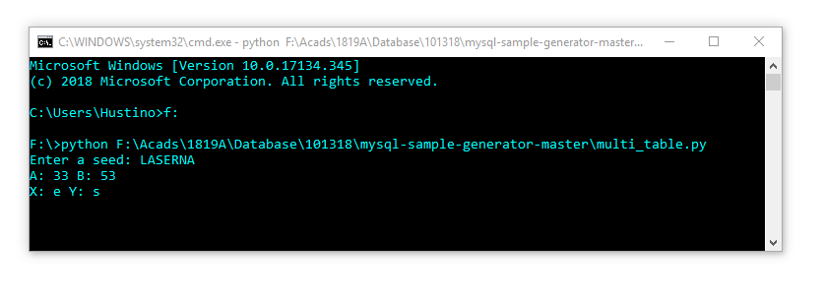

I. Total number of pages, average number of pages, maximum number of pages written by authors with first names that start with the letter R. Give the first 5 data sorted by the average number of pages. (*HINT: Join, Group)*

*SQL Query:*

SELECT Sum, Average, Max

FROM (

SELECT first_name,

SUM(pages) Sum,

AVG(pages) Average,

MAX(pages) Max

FROM books b

LEFT JOIN authors a ON a.id=b.author_id

GROUP BY first_name

HAVING a.first_name LIKE 'r%'

ORDER BY 3

) as tempo

LIMIT 5;

*Table output:*

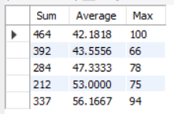

*Table 1*

II. Book titles with pages greater than the average number of pages done by its author. Return the first 5 titles sorted alphabetically. *(HINT: Correlated Subqueries, Group)*

*SQL Query:*

SELECT b.title

FROM books b

WHERE pages >

(

SELECT AVG(pages)

FROM books b2

WHERE b.author_id = b2.author_id

)

ORDER BY 1 -- or ORDER BY title

LIMIT 5;

*Table output:*

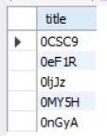

*Table 2*

III. Authors first name and last name who have written 2 or more books with pages greater than the number of the average pages done by all authors. First 5 sorted by last name then first name. *(HINT: Correlated Subqueries, Subquery with a Subquery)*

*SQL Query:*

SELECT first_name `First Name`, last_name `Last Name`

FROM authors a

WHERE (SELECT count(*) FROM books b

WHERE b.author_id = a.id

and b.pages>(SELECT AVG(pages) FROM books)

) >= 2

ORDER BY a.last_name, a.first_name

LIMIT 5;

*Table output:*

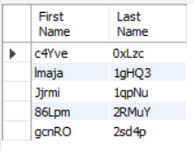

*Table 3*